Low-Frequency Vocabulary

🧬 What is Low-Frequency Vocabulary
# Source: AI Source: Provided by: [Data Path: Persons Table -> ID Column: 1, Name_En Column: Motasem Essam] -> From: [Chatgpt (GPT-4-turbo)] on [7/30/2025]
Low-frequency vocabulary consists of words that are rarely used in everyday language. These words are typically domain-specific, archaic, technical, or literary, and are usually known only by specialists or encountered in advanced reading materials.

✅ Key Features:
# Source: AI Source: Provided by: [Data Path: Persons Table -> ID Column: 1, Name_En Column: Motasem Essam] -> From: [Chatgpt (GPT-4-turbo)] on [7/30/2025]
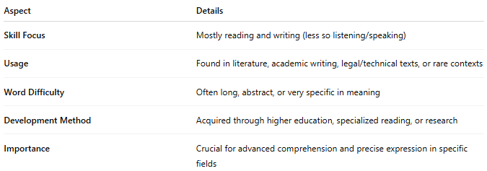
Aspect | Details
Skill Focus | Mostly reading and writing (less so listening/speaking)
Usage | Found in literature, academic writing, legal/technical texts, or rare contexts
Word Difficulty | Often long, abstract, or very specific in meaning
Development Method | Acquired through higher education, specialized reading, or research
Importance | Crucial for advanced comprehension and precise expression in specific fields

🧠 Examples:
# Source: AI Source: Provided by: [Data Path: Persons Table -> ID Column: 1, Name_En Column: Motasem Essam] -> From: [Chatgpt (GPT-4-turbo)] on [7/30/2025]
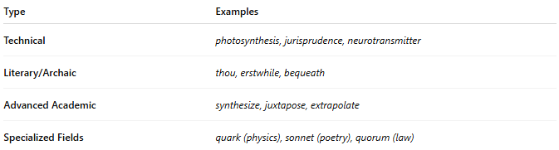
Type | Examples
Technical | photosynthesis, jurisprudence, neurotransmitter
Literary/Archaic | thou, erstwhile, bequeath
Advanced Academic | synthesize, juxtapose, extrapolate
Specialized Fields | quark (physics), sonnet (poetry), quorum (law)

👤 Who Uses It?
# Source: AI Source: Provided by: [Data Path: Persons Table -> ID Column: 1, Name_En Column: Motasem Essam] -> From: [Chatgpt (GPT-4-turbo)] on [7/30/2025]
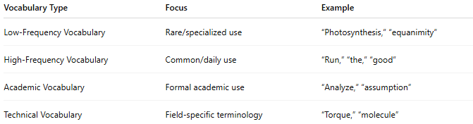
- Academics and researchers
- Writers and poets
- Professionals in specialized fields
- Advanced language learners

📌 Related Vocabulary Types:
# Source: AI Source: Provided by: [Data Path: Persons Table -> ID Column: 1, Name_En Column: Motasem Essam] -> From: [Chatgpt (GPT-4-turbo)] on [7/30/2025]
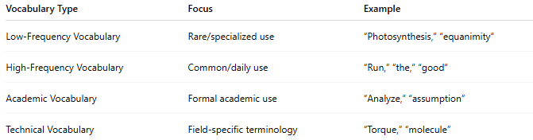
Vocabulary Type | Focus | Example
Low-Frequency Vocabulary | Rare/specialized use | “Photosynthesis,” “equanimity”
High-Frequency Vocabulary | Common/daily use | “Run,” “the,” “good”
Academic Vocabulary | Formal academic use | “Analyze,” “assumption”
Technical Vocabulary | Field-specific terminology | “Torque,” “molecule”

